

Southern California Edison
CS Re-Platform Project

CIM-CS-04: Handle Trouble and Outage Calls – Process Trouble Call
Customer Interaction Management
Business Process Design
Version 1.5

Table of Contents
1 Business Process Overview 5
1.1 Current Pain Points for Southern California Edison 5
1.2 Responsible Parties 6
1.3 Document Control 6
1.4 Terminology 6
2 Business Process Design 8
2.1 Trouble and Outage Call Details 8
2.2 Process / Performance Improvement 13
2.3 Prerequisites and Inputs 13
2.4 General Assumptions 13
2.5 Business Process Hierarchy 13
2.6 Process Flows 15
2.6.1 Create Trouble Order 15
2.7 3rd Party and SCE Legacy System Integrations 17
2.8 Data Elements 17
2.8.1 Business Partner Search (Basic) 17
2.8.2 Business Partner Search (Advanced) 18
2.8.3 Search Contract Account 19
2.8.4 Search Premise 20
2.8.5 Create Service Order 21
2.8.6 Change Service Order 22
2.8.7 Service Order List 22
2.8.8 Non-SCE Customer and Non-Standard Address 24
2.8.9 Source Systems and Data Volumes 25
2.9 Cloud for Customer (C4C) Integration 25
2.9.1 Processes 25
2.9.2 C4C Views 26
2.9.3 Activity 26
2.10 Exception Management Requirements 26
2.11 Process Risks and Mitigation 26
2.12 Key Performance Indicators 26
2.12.1 Key Metric Definition 27
3 Controls, Regulatory Rules, and Security 28
3.1 Security Considerations 28
3.2 Custom Program/Transaction Codes 28
3.3 Custom Table/Transaction Codes 29
3.4 Data Criticality and Cybersecurity Baseline Risks 29
4 Technical Considerations 31
4.1 RICEF-W Assessment 31
4.1.1. Reports 31
4.1.2 Interfaces 31
4.1.3 Conversion 31
4.1.4 Extension/Enhancements 31
4.1.5 Forms 32
4.1.6 Workflows 32
4.2 IDEX Considerations 32
4.3 Production System Cut-over Considerations 32
4.4 Other Considerations 32
5 Change Management 33
5.1 5.1 Change Impacts 33
6 Requirements 37
7 Appendix 38

This page intentionally left blank

Business Process Overview
An SAP work order is used as a document to log when trouble is reported related to power outages and other types of trouble (e.g., wire down). The work order will provide details required by field workers such as the type of trouble, requested date, requested time, notes containing access instructions and details about the trouble reported, tasks, customer, location, etc. These orders are then routed to the appropriate T&D system and personnel to be completed.
There are several scenarios that will require an order to be sent to the field and they are differentiated by category in order for right type of skilled resource assignment to carry out the task(s).
Example of potential scenarios may include:
- Trouble (e.g., wire down, pole leaning)
- Repair Outage (unscheduled, e.g. car hit pole)
- Rotating Outage (controlled outages to mitigate grid instability issues)
- Maintenance Outage (scheduled outages to complete maintenance on SCE’s electrical system e.g., replace transformer)
This document captures the process for the creation of Service Orders (SO) for trouble and outage calls via Hybris C4C to integrate with the Work Management (WM) processes for SCE.

Current Pain Points for Southern California Edison
- CSS has data issues therefore many users are forced to call in to report an outage instead of reporting through SCE.com and the SCE application.
- Outage alerts to customer are not always timely.
- No visibility to fringe addresses in system
- Data used to notified impacted customers is stored in multiple systems and can get out of synch (e.g., customer contact info and alert preferences, transformer information, etc.)
- We use multiple communication systems today to notify customers about different events (e.g., SDP events, outage, Budget Assistance) and communications cannot be prioritized
- SCE.com and outage maps are on two different platforms
- Transformer load management (customer-device relationship, grid/transformer/device hierarchy): data quality not good or hierarchy missing
- Inaccurate FERT (forecasted estimated restoration time). Based on order type, sub type, area, safety: prioritization is based on existing grid map)
- SCE.com: No outage report confirmation number provided.
- Outage notification enrollments for residential and small business requires that the customer receive notifications for all addresses on their account, Cannot request notifications for a single address if they have multiples.
- Outage notifications (ONI) has no global preference center for the customer to manage all their notifications.

Responsible Parties
Contact | Contact Person
Southern California Edison Business Process Owner | Janet Covington
Southern California Edison Lead | Christine Evans
HCL Functional Lead | Adrianus Halim
Solution Architect | Pedro Costa
Front Office or Back Office Lead | Christine Evans
Subject Matter Experts | Deborah Tillman, Scott Long, Kristen James, Scott Hirth, Janine Aumont
Key User Group | Customer Contact Center (CCC), BCD

Document Control
Version | Description of Change | Date | Author
1.0 | Creation of Initial Version | 03/13/2018 | Jessica Marsillo
1.1 | Updates to Process Flow Steps | 04/13/2018 | Jessica Marsillo
1.2 | Updates from Pedro | 04/16/2018 | Jessica Marsillo
1.3 | Updated Figure 5 Screenshot | 04/24/2018 | Jessica Marsillo
1.4 | Updated RTM | 04/25/2018 | Jessica Marsillo
1.5 | Updates from BPD Walkthrough | 05/08/2018 | Adrianus Halim

Terminology
Term/Acronym | Definition and SAP Equivalent (if applicable)
APSE | Accelerated (or Axon) Project Support Environment
BDEX | SAP add-on functionality to support the processing of BPEM Cases
Billing Cycle | Is a group of contracts to be billed together via date-driven or regional criteria, it controls the billing cycle and is linked to the Meter Reading Unit. SAP equivalent term is the Portion.
Billing Document | A document that outlines the charges incurred for energy consumption for a specific contract. During the process of Billing, a billing document is generated for each contract on a contract account.
BMD | Business Master Data. The customer information which includes personal details, payment terms, dunning levels, billing rates and rate categories. The business master data objects are Business Partner, Business Agreement/Contract Account and Contract.
BPD | Business Process Design (or Document)
BPEM | Business Process Exception Management
BWR | Basic Work Request. SAP equivalent is BPEM.
CA | Contract Account
Channel | Data object in SAP that holds the interval data. Intervals can be kwh, price, factor, etc. SAP equivalent is Profile.
Clarification | A list of payments that could not be processed and require additional work in order to be posted.
Connection Object | Link between installation and postal regional structure. Usually a building, but can also be a piece of property or other facility, such as a fountain or construction site. The connection object corresponds to the functional location in plant maintenance (PM).
Contract | Standard SAP object that is used to link SAP Business Master Data and Technical Master Data through the move-in process
Customer | Any entity with a relationship with SCE. This term is usually used in reference to customers (both individuals and organizations) This can include employees and third party suppliers (banks and payment partners). SAP Equivalent is Business Partner (BP)
EAM | SAP Enterprise Asset Management
Front Office Process | Front Office Process or FOP is one of the SAP components that allows you to configure series of steps (or front office steps) in order to complete a transaction. The steps mostly contain the most frequent processes and most important information
Hybris C4C | SAP Cloud for Customer Solution
IMG | SAP Implementation Guide – where configuration is performed
Level Pay Plans | SAP equivalent term is Budget Billing. Budget Billing allows customers to pay regular equal amounts over a yearly period.
Mashup | This is part of standard C4C features allowing to integrate data from applications and online web services. SAP C4C has pre-configured mashups; they are as follows:  - URL Mashup  - HTML Mashup  - Data Mashup  - Custom Mashup
Premise | Represents one of the SAP Technical Master Data object that is supplied with energy, for example, an apartment or factory. A premise can have several utility installations. The premise is allocated to a connection object and the address of that connection object
S/4HANA | SAP HANA 4 Business Suite
SCE | Southern California Edison
Service Notification | As part of Plant Maintenance Module, this is to handle event of malfunction or exceptional situation - to describe the technical condition for an object subject of the issue and then forward the request to maintenance department in order to perform the right tasks.
Service Order | A work order to record the details of a one-off service agreed upon by a service provider and a service recipient. Service orders contain all the information needed to plan, execute, and bill for a service
Summary Billing | Standard SAP functionality that enables the invoicing of multiple Contract Accounts under one Parent Contract Account (Consolidated Summary Billing). SAP equivalent is Collective Billing.
TCODE | Transaction Code Description
TMD | SAP Technical Master Data e.g. Connection Object, Premise and Device Location
Additional terms may be found in APSE General Document # 32 CSRP Glossary

Business Process Design

Trouble and Outage Call Details
An Outage is a situation when the Utility supply to a localized area affecting multiple premises is interrupted. A Trouble Order may be related to a power outage or other types of trouble such as Pole Leaning, Wire on Ground or Transformer leaking.
When trouble is reported, we attempt to collect the location (address or cross streets), type of trouble (e.g., No lights, streetlight out, wire in tree) and any other details we can collect to help field personnel locate, isolate and correct the problem. The person reporting the trouble may or may not be the customer of record.
Trouble is reported to SCE through one or more of the following channels:
- Customer and non-customers can call and speak with an SCE employee, use the IVR, report it via social media, submit it on SCE.com using the Outage Center or even walking into SCE facilities (e.g., service center)
- Emergency service employees (e.g., fire and police) may contact SCE related to outages and trouble
- SCE personnel may report trouble/outages they observe when they are out completing other types of work
Once the trouble/outage has been reported, a Service Order (SO) will need to be created. The SO will then be routed to the appropriate T&D system so it can be reviewed and assigned to the appropriate field personnel to be resolved. In order for the user to capture the fields needed for this type of SO, we will leverage an enhancement already identified that will support the enhancement E-CIM-CS-05 - Order Creation.
This document details the process to create and manage Trouble and Outage calls only via Hybris C4C.

    - Create Trouble Order (SCE Customer)
When creating a new SO via Hybris C4C, the user will normally need to confirm the appropriate objects (ex. Business Partner (BP) and / or Premise). With reference to Figure 1 below, they will then select the appropriate order type (via drop down), which will be a required field that drives the assignation of the appropriate field staff to the order based on the order type (Refer to BPD DF-WM-02: Handle Field Orders – Manage Field Orders for order list). Note: Today trouble orders have a type and sub type, but in C4C we will need to concatenate the type and sub type into one field (e.g., Trouble – No Lights). The Start Date/Time will default to current date/time and the user can also provide additional details in the description field to support the field personnel to investigate/resolve the issue. The user will then submit the order.
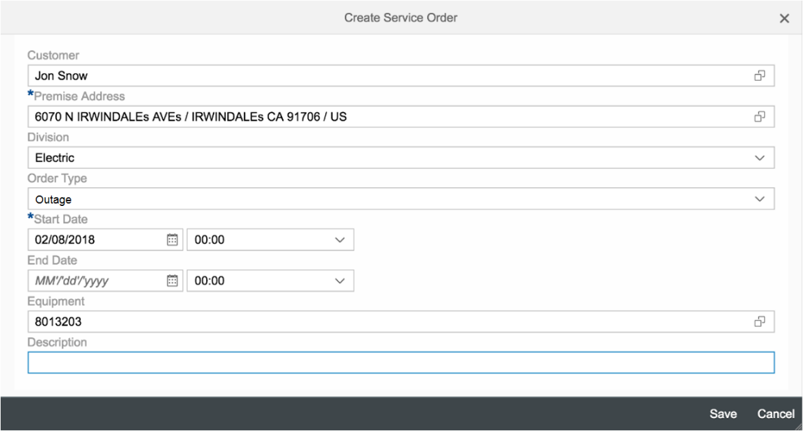

Figure 1 – Create a New Service Order

Once a new SO has been created, the order will be handled based on what is required in order to get the assigned tasks done. This will be covered in BPD: DF-WM-02 - Handle Field Orders - Manage Field Orders. If the person reporting the trouble wishes to receive status updates, the user can update their outage alert preferences for the account or they can request to only receive updates on the specific trouble order that they reported. This is covered in enhancement E-CIM-CS-01: Manage Preference.

    - Create Trouble Order (Non-SCE Customer)
There may be a scenario in which either the BP and/or the premise cannot be found due to the fact that the caller is not the customer of record or they are only able to provide limited information about the location (e.g., cross-street). This often occurs when someone is reporting a streetlight outage. Such callers can be categorized as non-SCE customers. The enhancement E-CIM-CS-05: Order Creation will be used to handle this scenario. (Figure 2: Non-SCE Customer and Non-Standard Address) The order type selection will be the main key component to be selected when determining the type of order as the starting point. Should the non-SCE customer wish to receive notifications regarding the SO, the user will utilize the appropriate fields under the Communication header shown in Figure 2. The outage notification will be covered in the BPD CIM-CS-11 - Manage Outbound Request. The field order notes can be utilized to record the additional problem reported by the caller, as well as breaker/fuse requirements if necessary. (Figure 3: Order Note Capturing Additional Information)

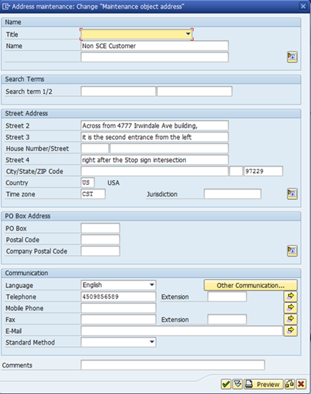
Figure 2 – Non-SCE Customer and Non-Standard Address

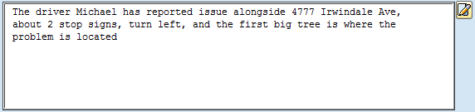
Figure 3 – Order Note Capturing Additional Information
The next step is to select a district by calling the enhancement E-DF-WM-02: District Determination to determine the dispatched area where particular service is required to be carried out. In addition to this, the field PM Activity Type is also used to categorize the job code from the drop-down field. These two fields and work order routing are to be further detailed in the BPD DF-WM-02: Handle Field Orders – Manage Field Orders.

    - Edit/Cancel Trouble Order
SOs can be modified or cancelled for a variety of reasons. Should a SO need to be modified or cancelled, it can be done in Hybris C4C by highlighting the order, selecting the ‘More’ button, and then selecting either ‘Edit’ or ‘Cancel’. If the SO is edited or cancelled, the system will automatically update work order in the system so that field personnel can be informed.

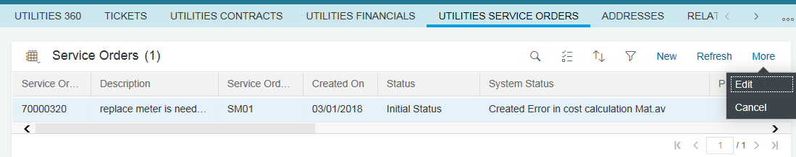
Figure 4 – Cancel Service Order

    - View Orders
SOs are viewable for a BP in Hybris C4C by searching and loading the BP and clicking on the Service Order view. Users can view the SO number, SO type, creation dates, status (open vs. completed, etc.) and premise address. (Figure 5 – View Order) The order status will be used as a reference by the user to determine where the order is at in its lifecycle (ex. in field, onsite, etc.). Overall this provides an overview to all field work orders related to the confirmed customer. With SAP C4C release 1805, the SO number will become a hyperlink, which will bring t-code IW33 from S/4HANA to Hybris C4C via FOP Figure 6 – Service Order). This will allow the user to see additional SO details that are related to that particular customer.

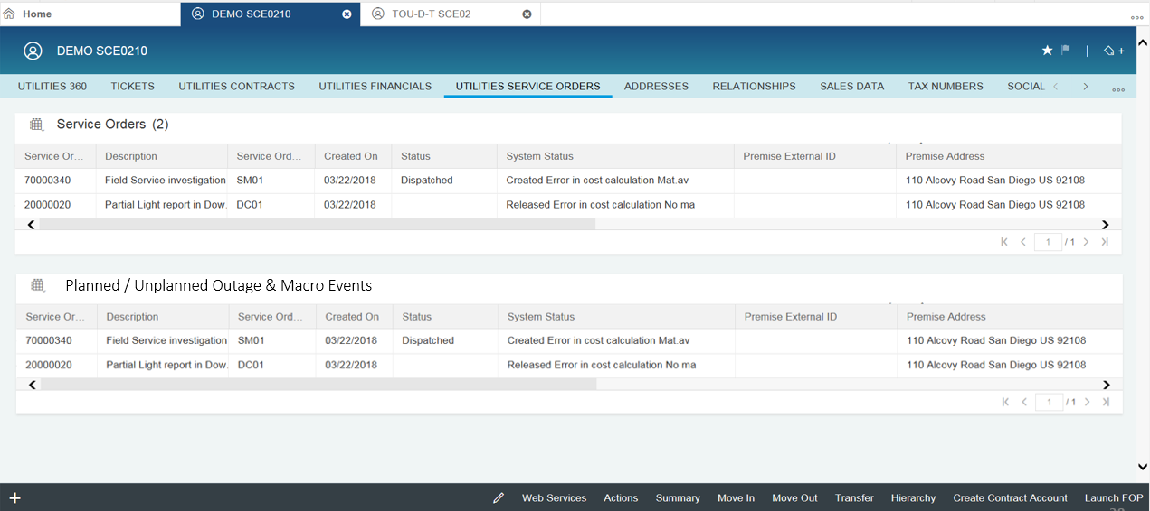
Figure 5 – View Order

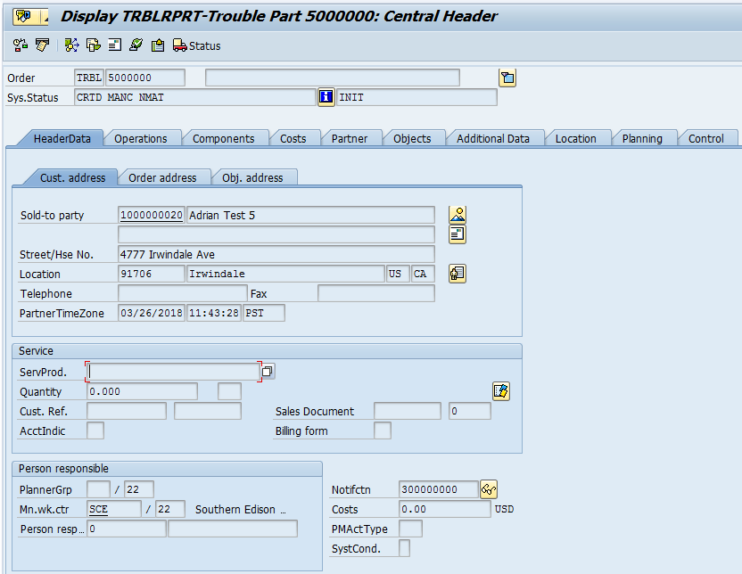
Figure 6 – Service Order

For those SOs that are created for non-SCE customers or customers who are part of outage, the orders can be seen in Figure 5 above in the section Planned/Unplanned and Macro Event. The user will be able to search by SO Number, OAN number, address, BP number and other parameters. This will be done via the enhancement E-CIM-CS-17 – C4C Outage View. A hyperlink will be provided so that the users can see the detail information about the order itself. Further feature will be provided via FOP in C4C (Figure 8) for the front office users to retrieve the list of orders that are only related to the trouble orders. The fields shown in Figure 7 can also be filled with fixed values to suit business needs.

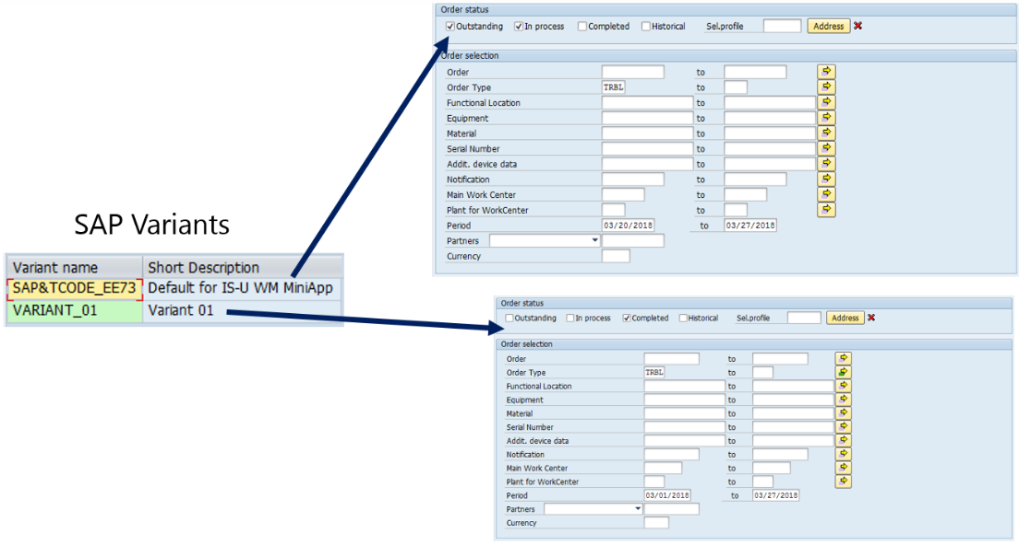
Figure 7– SAP Variants with different selection made

Once the search has been executed, the result list of alert overview will be shown like in Figure 8. The result list layout can be further configured to SCE business needs.
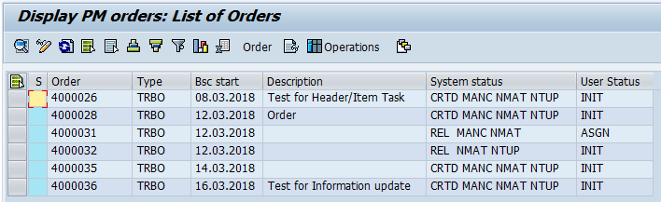
Figure 8 – Order list via FOP

Process / Performance Improvement
- The work orders will be stored in S/4HANA and there are useful standard SAP reports that can be used for order lifecycle improvement, order tracking, and customer service satisfaction.

Prerequisites and Inputs
- Order type
- Business Partner (Mandatory for SCE customers)
- Non-SCE customer when BP not found
- Premise (Mandatory for identified address)
- Non standard address for cross-street locations, etc.

General Assumptions
N/A

Business Process Hierarchy
This Business Process Hierarchy provides a listing of all scenarios/business processes, sub-processes, and SAP Transaction codes identified to support this process.
Level 1 | Level 2 | Level 3 | Level 4
Front Office  (CCC/BCD) | Process Field Work Request | Display Service Order | IW33
Front Office  (CCC/BCD) | Process Field Work Request | Service Order Report | IW39
Front Office  (CCC/BCD) | Process Field Work Request | Create Service Order  Change Service Order  Display Service Order | Hybris C4C  IW31  IW32  IW33
Front Office  (CCC/BCD) | Process Field Work Request | Utility Service Order | Hybris C4C
Back Office  (T&D) | Process Field Work Request | Display Service Order | IW33
Back Office  (T&D) | Process Field Work Request | Service Order Report | IW39
Back Office  (T&D) | Process Field Work Request | Create Service Order  Change Service Order  Display Service Order | IW31  IW32  IW33

Process Flows

2.6.1 Create Trouble Order

Process Flow Diagram

Process Flow Steps

Step | Description of Step | T-Code | Role(s) | If step is relevant for a Control, add Requirement  ID
10 | Start  Customer starts Trouble Order request at IVR/SCE.com. Proceed to Step 30. | N/A | IVR/SCE.com
20 | Start  Front Office Agent receives request from the customer. Proceed to Step 80 | N/A | Field Work Order Processing – CCC/BCD
25 | Start  Customer request via IVR receives request from the customer. Proceed to Step 70 | N/A | Field Work Order Processing – CCC/BCD
30 | Create Trouble Order | S/4HANA  IW31 | S/4HANA
40 | Successful?  Decision point – Was the Trouble Order created successfully? If yes, go to Step 50. If no, go to Step 60. | S/4HANA | S/4HANA
50 | Create Customer Contact  A Customer Contact is automatically created to log the successful creation of the Trouble Order for the customer. Once complete, go to Step 120. | S/4HANA  BCT0 | S/4HANA
60 | Create Case  If the creation of the Trouble Order fails, an automatic BPEM case is created. Once complete, go to Step 120. | S/4HANA  EMMAC1 | S/4HANA
70 | Call Routed to Agent | N/A | Field Work Order Processing – CCC/BCD
80 | Manage Business Partner | Hybris C4C  BP | Field Work Order Processing – CCC/BCD
90 | Premise Required?  Decision point – Is the creation premise required to create the Trouble Order? | Hybris C4C | Field Work Order Processing – CCC/BCD
100 | Create Trouble Order | Hybris C4C  IW31 | Field Work Order Processing – CCC/BCD
110 | Create Activity  An activity will be manually created to log the successful creation of the Trouble Order for the customer. Once complete, go to Step 120. | Hybris C4C | Field Work Order Processing – CCC/BCD
120 | Manage Field Orders  Orders will be fulfilled by DF-WM-02. | S/4HANA | Field Work Order Processing
130 | End  The process ends. | N/A | N/A

3rd Party and SCE Legacy System Integrations
3rd Party or SCE Legacy System Integration | Description of Integration and Required Change to 3rd Party or SCE Legacy System | Estimated Complexity of 3rd Party or SCE Legacy system change

Data Elements
The information that will be captured for the below data elements will be defined as the intent of use for this BPD.

2.8.1 Business Partner Search (Basic)
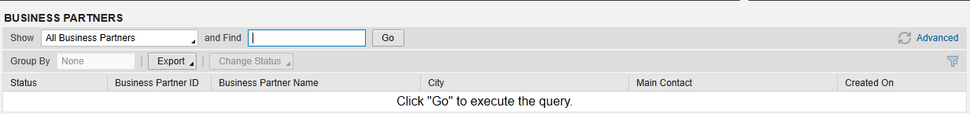
The following data elements will be used by the Business Partner Search (Basic).
Field | Type | Comments
Find | Required | Business Partner Number

2.8.2 Business Partner Search (Advanced)
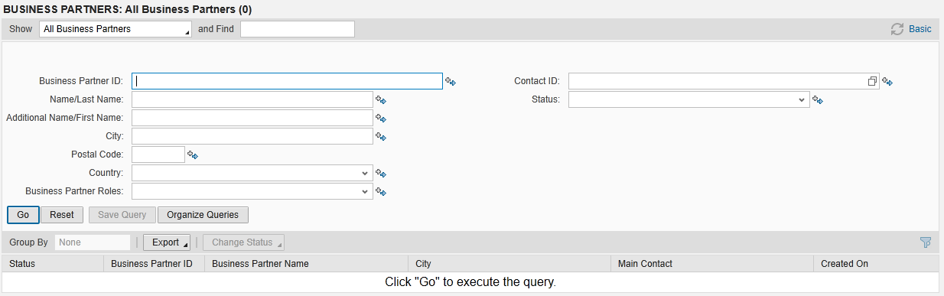
The following data elements will be used by the Business Partner Search (Advanced).
Field | Type | Comments
Business Partner ID | Optional | Business Partner Number
Name/Last Name | Optional | Business Partner’s Last Name
Additional Name/First Name | Optional | Business Partner’s First Name
City | Optional | City of Business Partner’s Address
Postal Code | Optional | Postal Code of Business Partner’s Address
Country | Optional | Country of Business Partner’s Address
Business Partner Roles | Optional | Example: Sold-to-Party (Refer to BP BPD)
Contact ID | Optional | N/A to SCE
Status | Optional | N/A to SCE

2.8.3 Search Contract Account
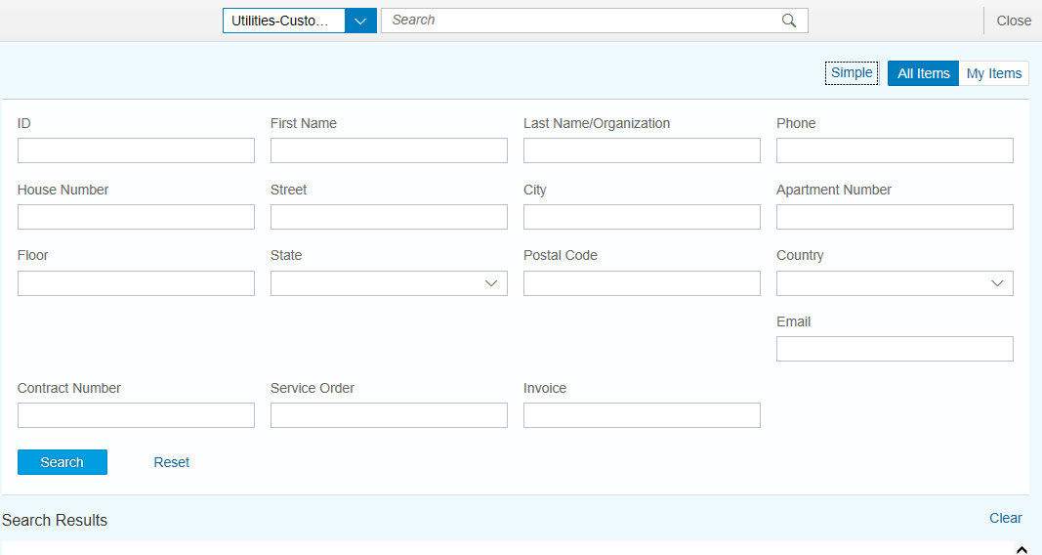
The following data elements will be used by the Contract Account Search.
Field | Type | Comments
ID | Optional | Business Partner Number
First Name | Optional | Business Partner’s First Name
Last Name/Organization | Optional | Business Partner’s Last Name/Organization Name
Phone | Optional | Business Partner’s Phone Number
House Number | Optional | House Number of Business Partner’s Address
Street | Optional | Street of Business Partner’s Address
City | Optional | City of Business Partner’s Address
Apartment Number | Optional | Apartment Number of Business Partner’s Address (House Number Supplement)
Floor | Optional | N/A to SCE
State | Optional | State of Business Partner’s Address
Postal Code | Optional | Postal Code of Business Partner’s Address
Country | Optional | Country of Business Partner’s Address
Email | Optional | Business Partner’s Email Address
Contract Number | Optional | Contract Number
Service Order | Optional | Service Order Number
Invoice | Optional | Invoice Number

2.8.4 Search Premise
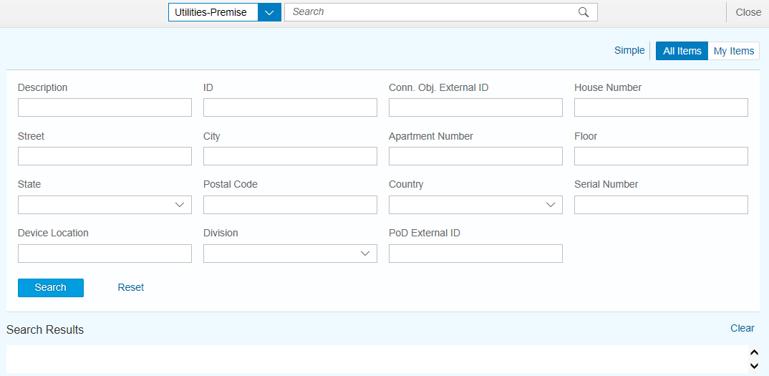
The following data elements will be used by the premise search.
Field | Type | Comments
Description | Optional | N/A to SCE
ID | Optional | Premise Number
Conn. Obj. External ID | Optional | Connection Object Number
House Number | Optional | House Number of Business Partner’s Address
Street | Optional | Street of Business Partner’s Address
City | Optional | City of Business Partner’s Address
Apartment Number | Optional | Apartment Number of Business Partner’s Address
Floor | Optional | N/A to SCE
State | Optional | State of Business Partner’s Address
Postal Code | Optional | Postal Code of Business Partner’s Address
Country | Optional | Country of Business Partner’s Address
Serial Number | Optional | Meter Serial Number
Device Location | Optional | Device Location Number
Division | Optional | Example: Electric, Gas, Water
PoD External ID | Optional | PoD ID Number

2.8.5 Create Service Order
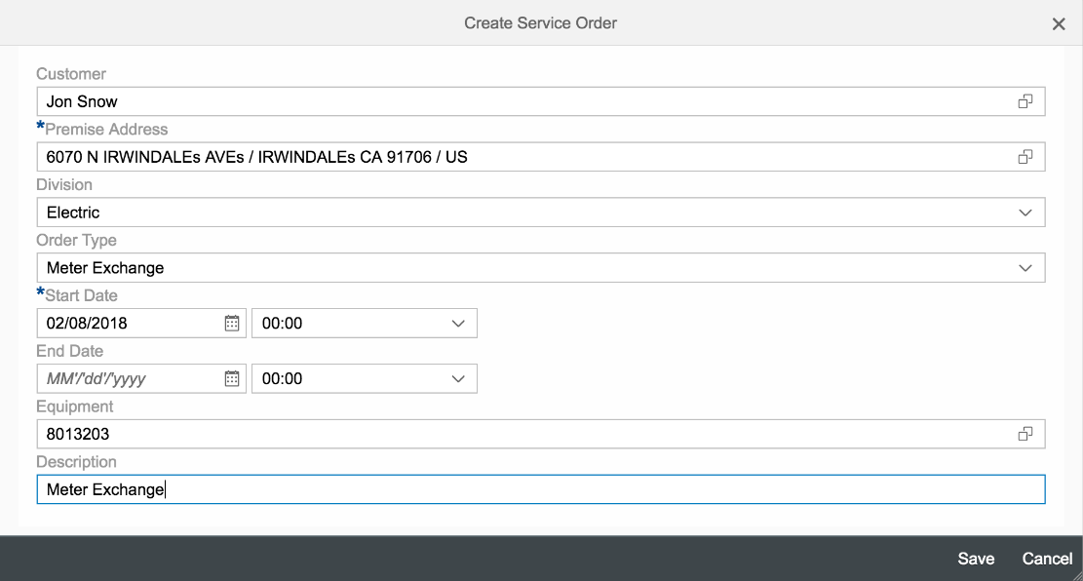
The following data elements will be used by the service order creation.
SCE Customer
Field | Type | Comments
Customer | Required | Business Partner
Premise | Required | Address where electricity service is provided
Division | Required | Example: Electricity, Gas, Water, Streetlight, Added Facilities
Order Type | Required | Type of Service Order to be created
Start Date | Required | Start Date of Service Order
End Date | Required | End Date of Service Order
Equipment | Required | Equipment Number
Description | Required | Explanation of Service Order

2.8.6 Change Service Order
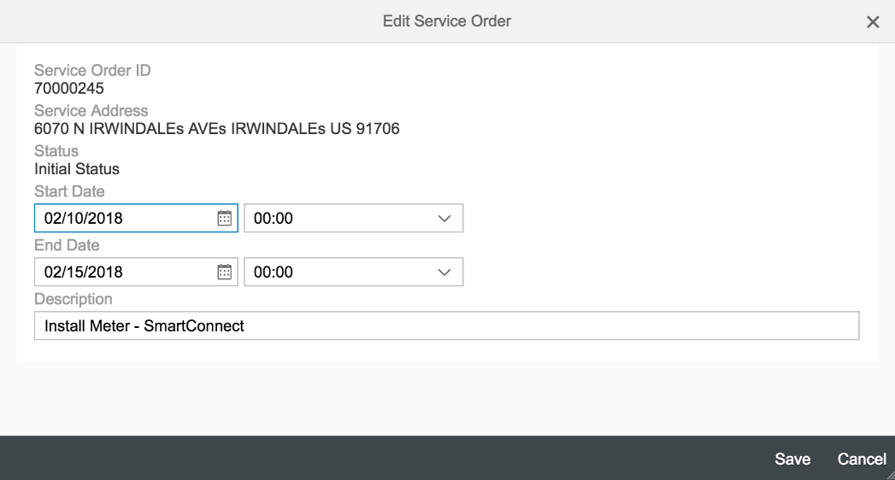
The following data elements will be used by the change service order.
Field | Type | Comments
Service Order ID | Display | Service Order Number
Service Address | Display | Address where electricity service is provided
Status | Display | Status of Service Order
Start Date | Edit | Start Date of Service Order
End Date | Edit | End Date of Service Order
Description | Edit | Explanation of Service Order

2.8.7 Service Order List
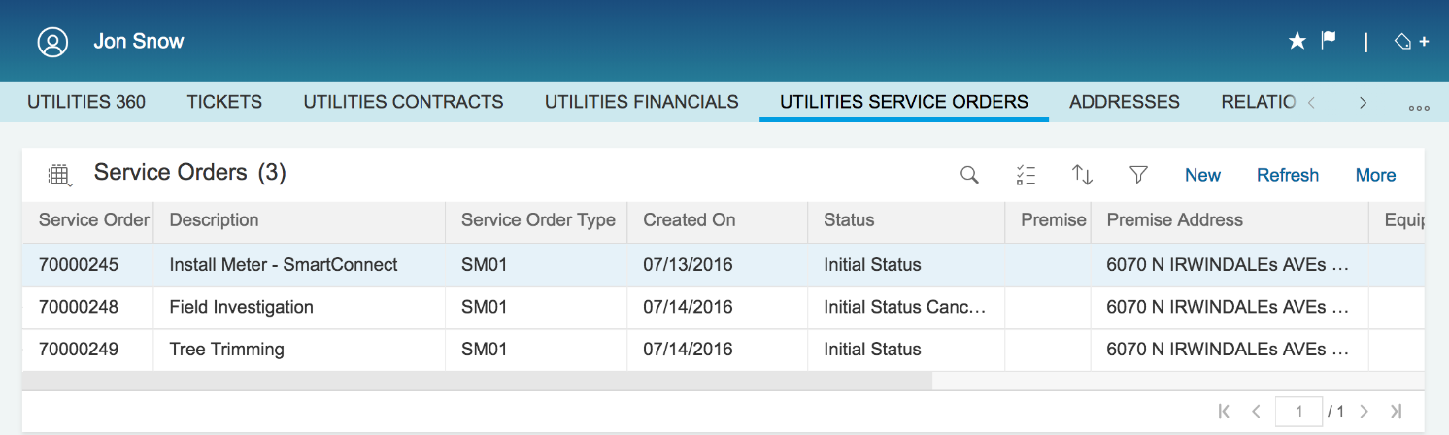
The following data elements will be used by the service order display.
Field | Type | Comments
Service Order | Display | Service Order Number
Description | Display | Explanation of Service Order
Service Order Type | Display | Service Order Type
Created On | Display | Date Service Order was Created
Status | Display | Status of Service Order
System Status | Display | System Message
Premise External ID | Display | N/A for SCE
Premise Address | Display | Address where electricity service is provided
Equipment | Display | Equipment Number
Division | Display | Example: Electricity, Gas, Water, Streetlight, Added Facilities
Start Date | Display | Start Date of Service Order
End Date | Display | End Date of Service Order
Start Time | Display | Start Time of Service Order
End Time | Display | End Time of Service Order

2.8.8 Non-SCE Customer and Non-Standard Address


The following data elements will be used by for non-SCE customers and non-standard addresses.
Field | Type | Comments
Title | Optional | Form of Address
Name | Optional | Name of non-SCE customer
Search term1/2 | Optional | N/A to SCE
Street 2 | Required | Details of location where non-SCE customer is reporting outage (i.e. cross streets, landmarks, etc.)
Street 3 | Optional | Continuation of details of location where non-SCE customer is reporting outage (i.e. cross streets, landmarks, etc.)
House Number/Street | Optional | N/A
Street 4 | Optional | Continuation of details of location where non-SCE customer is reporting outage (i.e. cross streets, landmarks, etc.)
City | Optional | City where outage is being reported
State | Optional | State where outage is being reported
Zip | Optional | Zip Code where outage is being reported
Country | Optional | Country where outage is being reported
Time Zone | Optional | N/A to SCE
Jurisdiction | Optional | N/A to SCE
PO Box | Optional | N/A to SCE
Postal Code | Optional | N/A to SCE
Company Postal Code | Optional | N/A to SCE
Language | Optional | N/A to SCE
Telephone | Optional | Phone number of non-SCE customer
Ext | Optional | Extension number of non-SCE customer
Mobile Phone | Optional | Mobile Phone number of non-SCE customer
Fax | Optional | Fax number of non-SCE customer
Email | Optional | Email of non-SCE customer
Standard Method | Optional | Preferred method of communication to non-SCE customer
Comments | Optional | Additional comments

2.8.9 Source Systems and Data Volumes

The following are completed Trouble Calls (orders) created by Call Center Reps/sce.com/IVR in the current CSS system:
Year | Completed Trouble Calls (orders)
2015 | 727,519
2016 | 769,416
2017 | 771,453
2018 (as of March 13th) | 114,788

Cloud for Customer (C4C) Integration

2.9.1 Processes
Trouble Orders can be handled in Hybris C4C and is available for Front Office agents to create, change and display Service Orders, as well as to search BP, search CA, and search Premise.

2.9.2 C4C Views
- Search BP (refer to Section 2.8.1 and 2.8.2)
- Search CA (refer to Section 2.8.3)
- Search Premise (refer to Section 2.8.4)
- Create Service Order (refer to Section 2.8.5)
- Change Service Order (refer to Section 2.8.6)
- Service Order List (refer to Section 2.8.7)

2.9.3 Activity
A new activity can be created when a new work order created or changed in the system

Exception Management Requirements
This section outlines a high level description of each BPEM Case or other user workflow items (such as “Tickets” used by Front Office) used to route work requests between business areas. The companion document for this section which outlines the detail of each case is documented in APSE on the Exception Case Template General Document #8.
User Exception Scenario / Description | User Group | Initiated by | Work Distribution
See the attached below

Process Risks and Mitigation
Risk Statement | Mitigation
If representative fails to update Service Order status, the Service Order will remain open even though the outage has been resolved. | Work Order report in S/4HANA (t-code IW39) will display open Outage Service Orders with certain date range.

Key Performance Indicators
The following have been identified as KPI’s at Southern California Edison, along with the means of measuring each KPI and the current measurement statistic for each KPI:
Measured KPI | Description | Measurement Method | Current Statistic
Outage Call AHT (secs) |  | Report | 261
Outage Calls per Impacted Customer ≤ 40.7% | Reduce live agent calls from customers impacted by an outage: percent of impacted customers who call a live agent ≤ 40.7% (excluding major storm days) | Dashboard
Reinstatements | Number of Lights Out in Error that were reinstated. | Report

2.12.1 Key Metric Definition
The following have been identified as key metrics at Southern California Edison that require business rule for calculation:
Key Metric | Description | Business Rule | Reference
N/A | N/A | N/A | N/A

3 Controls, Regulatory Rules, and Security
Requirement  ID (from RTM) | “As-Is” Control Requirement | “To Be” Risk Statement | “To-Be” Control Activity” | Control Automation (manual, IT dependent- manual, automated | Relevant technical identifier or RICEFW reference
N/A | N/A | N/A | N/A | N/A | N/A

3.1 Security Considerations

Role | Transaction Code (T-Code) | T-Code Description | Functional Restriction | Organizational Restriction
Trouble Call Processing – CCC/BCD | C4C (Workcenter: Call Center) | Display Work Order | Display
Trouble Call Processing – CCC/BCD | C4C (Workcenter: Call Center) | Create Work Order | Create
Trouble Call Processing – CCC/BCD | C4C (Workcenter: Call Center) | Change Work Order | Change/Cancel
Trouble Call Processing – CCC/BCD | C4C (Workcenter: Call Center) | Work Order Report | List work order
Trouble Call Processing – CCC/BCD | IW31 | Create Work Order | Create
Trouble Call Processing – CCC/BCD | IW32 | Change Work Order | Change/Cancel
Trouble Call Processing – CCC/BCD | IW33 | Display Work Order | Display
Trouble Call Processing – CCC/BCD | IW39 | Work Order Report | List work order

3.2 Custom Program/Transaction Codes

Custom Table | Authorization Grp Assigned | Custom T-code for the Table | Table Access (display/update) | RICEFW Reference ID
N/A | N/A | N/A | N/A | N/A

3.3 Custom Table/Transaction Codes

Custom Table | Authorization Grp Assigned | Custom T-code for the Table | Table Access (display/update) | RICEFW Reference ID
N/A | N/A | N/A | N/A | N/A

3.4 Data Criticality and Cybersecurity Baseline Risks
Specify Data Classification /Special Handling or Regulatory Requirement  What is the classification of Data? Does it trigger any special regulations?  Please select the classification / Sensitivity of the Data. This will help us Assess the Risk associated and remediation measures if any. | <Select all that apply>  ☐ PII - Personal Identifiable Information / Privacy Law  ☐ CEII - Critical Energy Infrastructure Information  ☐ FERC SOC (Standards of Conduct)  ☐ NERC CIP Confidential  ☐ Sarbanes-Oxley (SOX) financial reporting data  ☐ SCE utility data accessible by affiliate companies (CPUC)  ☐ PCI - Payment Card Industry Compliance  ☐ Customer Information Service Request (CISR, CISR-DRP)  ☐ Other _<Please Specify>_  ☒ Internal  ☐ Public  ☐ Confidential
Please identify which business Group/Role will require access to the data and/or solution:  Please select the list of Busines Groups will have access to this Data / Process. This will help us Determine the Impact and Risk Spread. Will ensure efficient Risk mitigation measures. | <Select all that apply>  ☒ SCE Customer, Res./Comm. Customer;  ☐ SCE OU, Business Function Organization Name:  ☐ Vendor  ☐ External business partner(s) & SaaS providers  ☐ External on-shore contractors  ☐ External off-shore contractors  ☐ SCE Affiliate Company Employees  ☐ SCE Employees, specify if they have Marketing Function responsibilities (e.g., ES&M)  ☐ SCE contract workers  ☐ Regulatory Agencies  ☐ Others _<Please Specify>_
How many of the SCE Customer, Employee, Vendors will use or affected by the Business Process?  To identify the Impact if services are adversely affected. | +10,000…
How much Information/data would be processed, received or tramitted by the Business Process?
The data volume that will be utilized by this process. Helps us in determining the Impact and criticality
Number of business transactions in average?
These are the number of transactions process by the application on average. The number of transactions help in understanding criticality and Impact.
Additional Security Consideration: | Any Cybersecurity impact in addition to SAP system security:  - Internet Facing Web Application? Yes/No, Details: No  - Internet Facing Application Programming Interface? OMS  - 3rd party Fedrated Authentication & Authorization, Single Sign On? Yes (OMS)

Technical Considerations

RICEF-W Assessment

Reports
Report Name & Description (List Requirements met by this Report) | Complexity | Reference ID
N/A | N/A | N/A

Interfaces
Interface Name & Description (List Requirements met by this Interface) | Complexity | Reference ID
System shall update necessary information when the outage/trouble order gets updated/cancelled | Medium | I-CIM-CS-04-0001 Trouble Order status update from OMS to CR&B
- Ability for a non-SCE customer to receive updates on the outage they have reported  - Ability for customers who requested to receive Report an Outage - Trouble Order Outage notifications for their one off outage to enroll in proactive notifications. | Medium | I-CIM-CS-04 Customer Notification

Conversion
Conversion Name & Description (List Requirements met by this Conversion) | Complexity | Reference ID
N/A | N/A | N/A

Extension/Enhancements
Extension Name & Description (List Requirements met by this Extension) | Complexity | Reference ID
- Ability to capture breaker/fuse requirements in trouble order  - Ability for users to create a new trouble order and link it to a closed/completed trouble order  - The system shall enable the user to enter the requester's trouble order contact information for notification updates, including phone or email address and notification method (e.g., email, voice, text or TTY). Note: The system only uses this contact information to provide updates on this this trouble order.  - Ability to pass key customer attributes such as red list, number of dogs to the trouble order processing system | Medium | E-CIM-CS-04 Work Order Custom View
- The system shall enable a user to view a dashboard and export all data to CSV or excel for the number of outage trouble orders issued by web, IVR and employee, including the follow-up channel preference (if provided) and the number of service accounts impacted by date/time range.  - The system (SAP) shall enable a user to view outage details in dashboard view | Medium | E-CIM-CS-04 Dashboard Custom View
- If a premise is currently impacted by a Macro Event, the system shall suppress the display of the estimated restoration date/time until the Macro Event ends.  - The system shall enable a user to view Macro outage event details including (at minimum), for a premise when there is an active event:  - Macro event ID  - Macro event start date/time  - Estimated Macro event close date/time  - Reason for Macro event  - Estimated number of impacted premises  - Event Info  - District  - Circuit  - Boundary | Medium | E-CIM-CS-17 – C4C Outage View

Forms
Form Name & Description (List Requirements met by this Form) | Complexity | Reference ID
N/A | Medium | F-CIM-CS-04 - Planned outage notification

Workflows
Workflow Name & Description (List Requirements met by this Workflow) | Complexity | Reference ID
N/A | N/A | N/A

IDEX Considerations
N/A

Production System Cut-over Considerations
- Pending trouble service orders will be migrated

Other Considerations
N/A

Change Management

5.1 Change Impacts
Change Element Short Description | Change Impact Category | Audience Group(s) | Impact | Business Effort
In SAP, a user will need to select a field work order based on a list. Depending on the list, there may be multiple work order requests and users will need to scroll down to select the appropriate work order. It will have an impact to the users handle time as well as increases the risk for selecting the incorrect order. SAP does allow for smart typing capability and will pare down the selections as you begin to type. In the current system, trouble and field basic work requests are separate transaction types. | Process;  Decision Making (193) | CS-CSOD-CCC All;  CS-BCD-All;  CS-CSOD-Consumer Affairs | Medium | Medium
Each trouble work order will generate a unique identification/tracking number. Currently, trouble order numbers can be recycled through so users have to concatenate with a district number and the trouble order number to make it a unique number. This will eliminate duplicates and make it easier to exchange order numbers with the field. | Process;  Benefit/Improvement (202) | CS-CSOD-CCC All;  CS-BCD-All;  T&D-TS&O-GridOps-Dispatch;  T&D-TS&O-GridOps-Troubleman;  CS-CSOD-Consumer Affairs | Low | Low
In SAP, there is no current functionality that has a listing of all outages within the area. Agents may need to use sce.com outage maps to view a list or some other process to review other outages in the area.  In current system, agents can view multiple outage listing that may be associated within the area. This window is called outage alert notes. (requirements pending) | Process (204) | CS-CSOD-CCC All;  CS-BCD-All;  CS-CSOD-Consumer Affairs | High | High
In SAP, agents can add different contact types based on customer preference (e.g. text, voice, etc.). Currently customer can only receive voice call back when calling in to report trouble order. Preferences allows for customer flexibility leading to customer satisfaction | Process;  Benefit/Improvement (205) | CS-CSOD-CCC All;  CS-BCD-All;  CS-CSOD-Consumer Affairs | Medium | Medium
SAP reports on notifications sent to the customer for outages based on channel type. This provides an ability to report on what was sent and when it was sent. CSS does not have this functionality currently. This should improve visibility on what notifications were sent to the customers. | Process;  Benefit/Improvement;  Technology (207) | CS-CP&S-All;  CS-BCD-All;  CS-CSOD-CCC All;  CS-CSOD-Consumer Affairs | Low | Low
SAP allows for the ability to attach a photo with a geotag on a trouble work order. This is useful for trouble work order with no known or no standard address. This is new functionality available with SAP. We do not have the ability to do either of these today in CSS. CCC and BCD will need to determine a process on how to receive photos from customers if we use this functionality. | Process;  Benefit/Improvement;  Technology (211) | CS-CSOD-CCC All;  CS-BCD-All;  CS-CSOD-Consumer Affairs | Low | Low
Reviewed and assessed current trouble order category types. Removed duplicate or low volume types. This will lower the amount of trouble categories to select from. It will easier to select from the revised category list to minimize order errors. Users will need to be trained on the correct process for the categories that are no longer available. | Process;  Benefit/Improvement (212) | CS-CSOD-CCC All;  CS-BCD-All;  CS-CSOD-Consumer Affairs | Low | Low
In SAP frontline agents have the ability to cancel trouble orders. Currently CCC does not cancel trouble orders. The current process requires agents to contact the DOCs to cancel trouble orders. There needs to be a review of controls/policies associated with cancelling trouble orders. Frontline users no longer have to contact anyone to cancel a request. | Process;  Benefit/Improvement;  Decision Making (213) | CS-CSOD-CCC All;  CS-BCD-All;  CS-CSOD-Consumer Affairs | Low | Low
SAP may provide less outage event history data than the current system. There are pending requirements to view the data that frontline users have today but is currently out of the box functionality. Frontline users may not have visibility to outage data that they have today. | Process (214) | CS-CSOD-CCC All;  CS-BCD-All;  CS-CSOD-Consumer Affairs | Medium | Medium

Below is a description of each:
Change Element Short Description: Describes the ‘As-Is’ scenario and what is changing.
Change Impact Category: Determined by asking the questions below.
- Staffing Levels - Is the work effort increasing or decreasing (staffing levels), and how (e.g., task automation, new process/tasks)?
- Job Roles - Will the responsibilities, authority, or required skills for a job or job roles change? Will people be reporting to new leaders? Will managers’ responsibilities change?
- Compensation / Performance - Will the changes have such an impact on roles of an individual that merits a change in how they are compensated or how their performance will be evaluated? What behaviors are rewarded and recognized?
- Organization Structure - Is the ownership of the Process or Data changing (think departments, jobs, or roles, not individuals)?
- Decision Making - Will any of the changes impact how decisions are made, by or between, business units / departments? Who makes them, how they determine the criteria for making a change?
- Culture Shift - Will organizational value systems impact the way change happens or be impacted by the change? What are the underlying values of the organization that will directly influence the way change will be accepted and how much work will ultimately be required to ensure successful outcomes for the business?
- Location / Facilities - Will the change impact the physical location where they process is being implemented or require changes to the facilities to enable the process to be effective?
- Process - Any change to the current process (e.g. manual process becomes automatic, or vice versa)? Are there new processes being introduced or an old process being decommissioned? Is there a requirement to change an existing business rule or business policy? Will new business rule or policy needs to be introduced and enforced or complied to?
- Regulatory/ Legal - Are there any legal / regulatory requirements that might be impacted
- Technology - Are other applications impacted (e.g., going away, becoming read-only), or are there new requirements (e.g., new SW / HW, new version)
- Benefit/Improvement - Will there be an improvement or benefit to any of the stakeholders because of this change. (Be sure to include any pain points that are being alleviated)
- Other - Are there emotional implications stemming from any of these changes (think of buy-in issues or fears)
Audience Group(s): These are the affected departments, divisions etc…
Impact: The following were used to determine the impact:

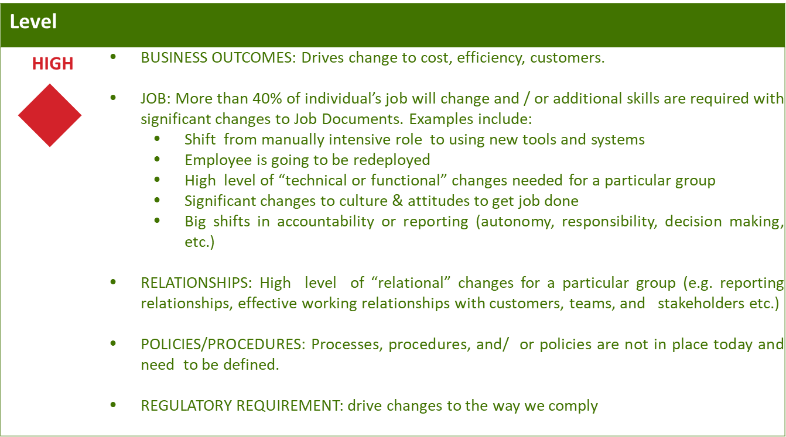
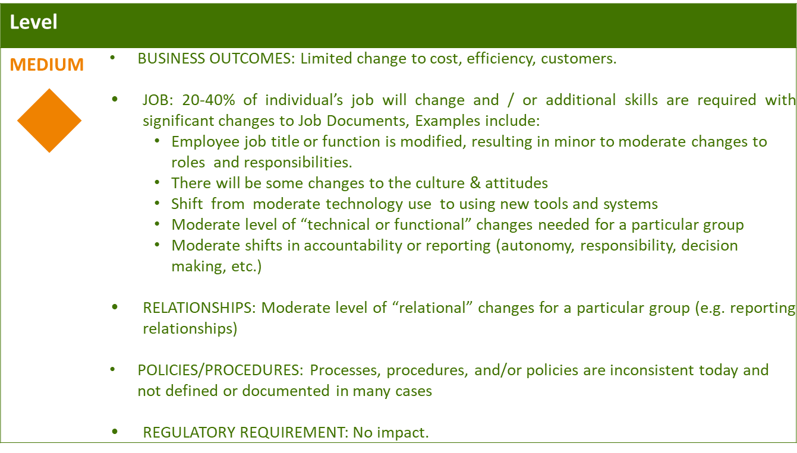
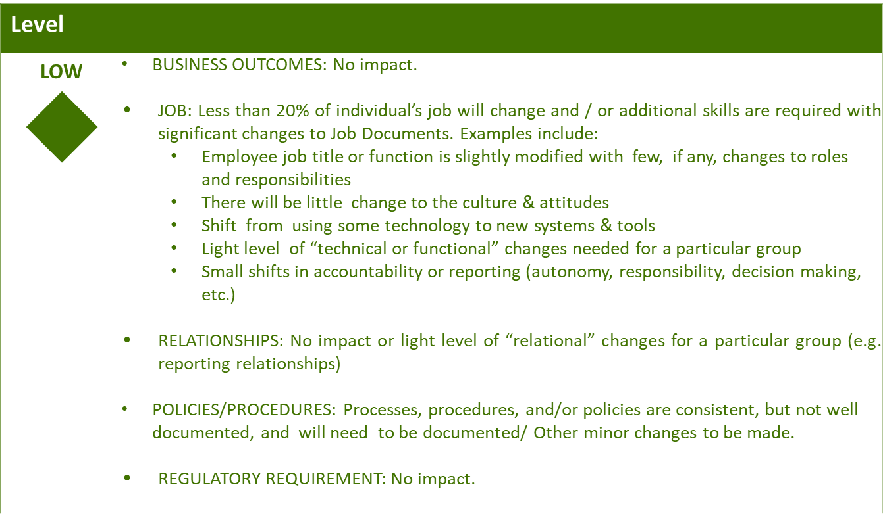

Business Effort: Initial assessment of the impact to the business High, Medium, Low

Requirements

Appendix

